CIRCUIT ANALYSIS LAB_2
Name: Muhammad Uzair
Reg No: 2025-CE-112
Date: 16thMarch,2026

Experiment # 1:
Circuit Made In Proteus:
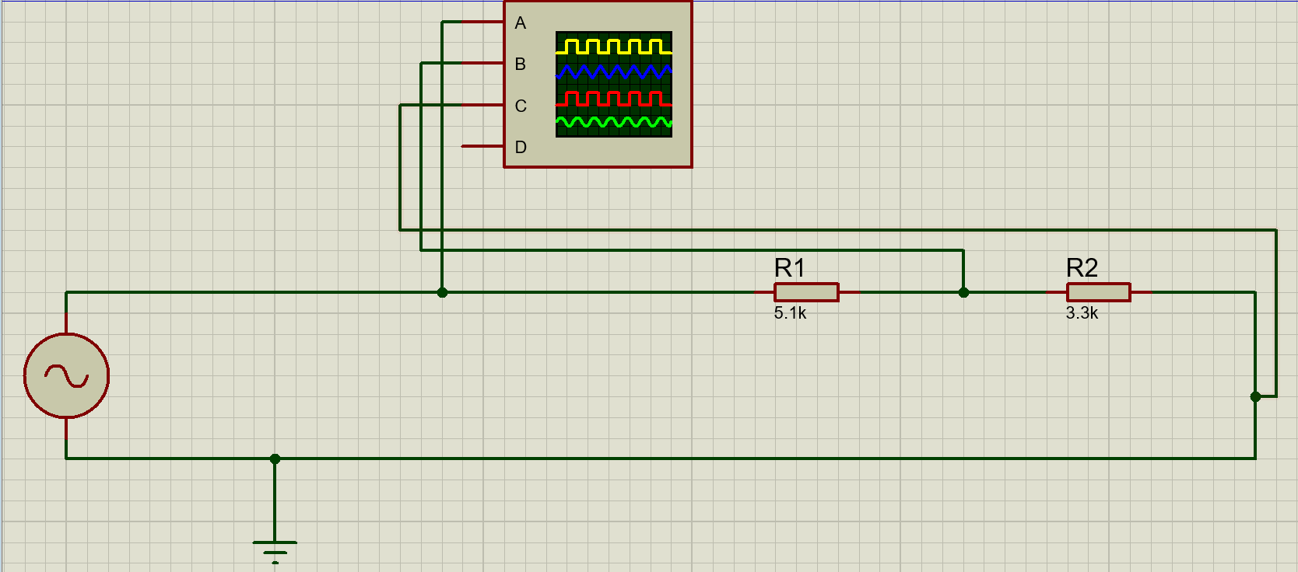
Construction:
- Insert Two Resistors R1 and R2 of 5.1kΩ and 3.3kΩ resistances respectively.
- Insert Oscilloscope and Generator from Instruments section.
- Connect Generator with R1.
- Connect R1 with R2 in series.
- Connect R2 with Generator and Also Insert Ground wire in between Generator and R2.
- Connect terminal A of Oscilloscope with Generator, B terminal in between R1 and R2 and C terminal in between R2 and Ground Node.
- Set Generator to V_{p-p} = 5V and Frequency = 100Hz.
- The Circuit According to the requirements is completed. Run it and Observe.

Experiment # 2:
Circuit Made In Proteus:
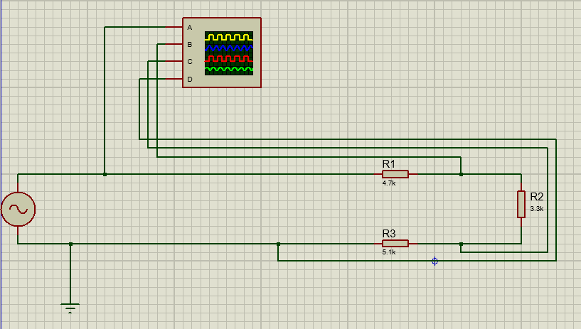
Construction:
- Insert Two Resistors R1, R2 and R3 of 4.7kΩ, 3.3kΩ and 5.1kΩ resistances respectively.
- Insert Oscilloscope and Generator from Instruments section.
- Connect Generator with R1.
- Connect R1, R2 and R3 in series.
- Connect R3 with Generator and Also Insert Ground wire in between Generator and R3.
- Connect terminal A of Oscilloscope with Generator, B terminal in between R1 and R2, C terminal in between R2 and R3 and D terminal in between R3 and Ground Node.
- Set Generator to V_{p-p} = 7V and Frequency = 200Hz.
- The Circuit According to the requirements is completed. Run it and Observe.

